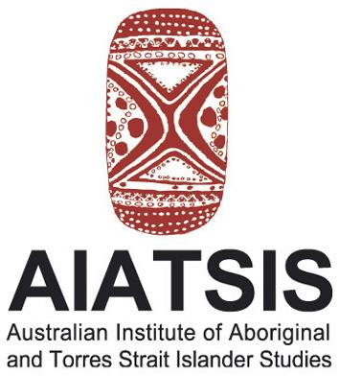
Media Release
______________________________________________________________
Worldwide knowledge and understanding of Australian Indigenous cultures, past and present

Tuesday, 12 December 2006

Aboriginal music comes to life in Stanner Award book

A book that explains how Aboriginal musical and ceremonial performances link the living with the dead has won the 2006 Stanner Award from the Australian Institute of Aboriginal and Torres Strait Islander Studies (AIATSIS).
Songs, Dreamings and Ghosts: The Wangga of North Australia by Allan Marett (Wesleyan University Press, Connecticut, 2005) studies the wangga, a musical and ceremonial genre of the Aboriginal people of Wadeye and Belyuen in the Daly region of the Northern Territory.
Professor Marett describes how Aboriginal musicians receive songs both from an eternal realm known as The Dreaming and from the ghosts of deceased ancestors. He offers an in-depth description and analysis of this compelling musical practice, including illustrations, notated music examples, and a music CD closely related to the text.
An expert reader for the award said the book was one of the most exciting he had read about traditional culture.
“It is contemporary in its attitudes, forward-looking, respectful, trenchant, cerebral, artistic, poetic and passionate. Marett is awed by what he has seen. He communicates clearly his wonder and admiration for the Indigenous achievement, without losing sight of the technical needs of the analysis,” the reader said.
“The CD is excellent…everything came to life at once,” he said.
The Stanner Award is awarded annually by AIATSIS to the best scholarly published contribution to Aboriginal and/or Torres Strait Islander Studies that reflects the dynamic nature of one of its founders, the late anthropologist Emeritus Professor W.E.H. (Bill) Stanner. The Award consists of a certificate and a $1000 cash prize to the winning author.
AIATSIS Chairperson Professor Mick Dodson said Songs was an engaging book that benefited from Professor Marett’s relationship with the Wadeye and Belyuen communities.
“Music and ceremony are the basis of traditional Aboriginal culture and Professor Marett has portrayed these so well by developing a meaningful and respectful relationship with Aboriginal people from these communities over 20 years,” Professor Dodson said.
“The result is an outstanding contribution to our knowledge of traditional Aboriginal culture.”

Media: AIATSIS Chairperson, Professor Mick Dodson on 0401 718 495 or Chris Ryan 0408 688 026

